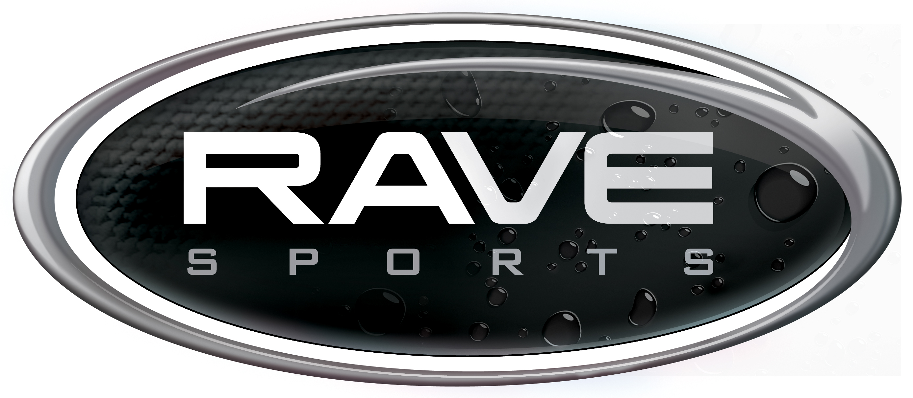
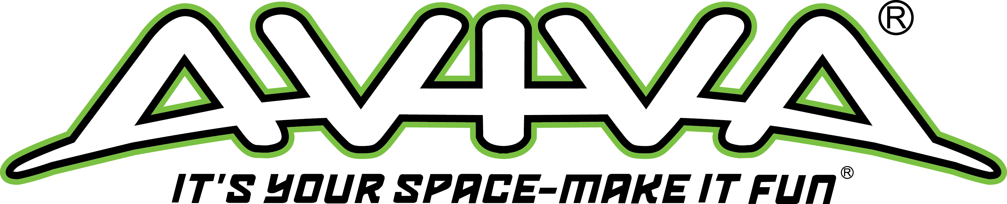

General Product Conformity Certificate

This is to certify that the

Mega Mambo™ towable (P/N 02367)

Imported by:
Indian Industries, Inc. (dba Escalade Sports/RAVE Sports/AVIVA Sports)
985 Aldrin Dr. #301
Eagan, MN 55121
800-659-0790

conforms to the following applicable rule, ban, standard or regulation:
(Check all that apply)

__X_ | 16CFR1303- Lead in paint/coatings  Cert. level = < 90ppm |  | ____ | ASTM F963-11 Toy safety
__X_ | CPSIA Section 101 (f)- Lead in coatings  Cert. level = < 90ppm |  | ____ | 16CFR 1500.44 – Flammability of solids in Children’s products
__X_ | CPSIA Section 101 (a)- Lead in substrate  Cert. level = <100ppm |  | ____ | 16CFR 1500.48/49, 1501- Sharp points/edges, Small parts in Children’s prod
____ | CPSIA Section 103 (a)- Tracking labels |  | ____ | Flammable Fabrics Act, 16CFR1610
____ | CPSIA Section 108 (a)- Phthalates in Children’s Toys |  | ____ | Other_Toxics in Packaging__

Mfr name: MD
Date(s) of manufacture: Oct. 2020 to present
City/Country of origin: Dongguan/ Peoples Republic of China

Third party testing, if required
Name of third party lab(s) whose testing the certificate depends:
 | SGS-CSTC Standards Technical Services Co. Ltd.
City & country of test lab: | Guangzhou, China
Test Report No(s): | GZHL2010052627OT
Testing date(s): | Oct. 20, 2020- Oct. 28, 2020

Contact person maintaining test records
Name: Tom Plante- RAVE Sports
Address: 985 Aldrin Dr. #301, Eagan, MN 55121
Email: tplante@ravesports.com
Phone: 800-659-0790
GCC Issue Date:_11/3/20__

